**Pizza Sales PROJECT QUERY**

**KPI’s:**

**-- 1. Total Revenue**

SELECT total_price FROM pizza_sales;

SELECT SUM(total_price) As TotalRevenue

FROM pizza_sales;

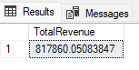

 -------------------------------------------------------------------------------------------------------

**-- 2. Average Order Value**

SELECT SUM(total_price) / COUNT(DISTINCT order_id ) As AverageOrder

FROM pizza_sales;

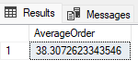

—----------------------------------------------------------------------------------------------------

**-- 3. Total Pizzas Sold**

SELECT SUM(quantity) AS Total_Pizza_sold

FROM pizza_sales;

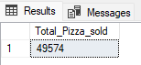

—---------------------------------------------------------------------------------------------------

**-- 4. Total Orders**

SELECT COUNT(DISTINCT order_id) As Total_orders

FROM pizza_sales;

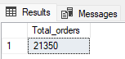

—-----------------------------------------------------------------------------------------------------

**-- 5. Average Pizzas per Order**

SELECT CAST(CAST(SUM(quantity) As DECIMAL(10,2)) /

CAST(COUNT(DISTINCT order_id) As DECIMAL(10,2)) As DECIMAL(10,2)) As Average_Pizza_per_order

FROM pizza_sales;

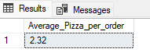

—-----------------------------------------------------------------------------------------------------

--  ----------------------- CHART -----------------------------------------------------------------

**-- 1. Daily Trend for Total Order**

**-- count total order by date wise**

-- count total order by date wise

SELECT order_date, COUNT(DISTINCT(order_id)) As Total_Order

FROM pizza_sales

GROUP BY order_date;

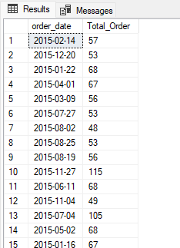

-- count total order by day wise

SELECT DATENAME(DW, order_date) As Days,

COUNT(DISTINCT(order_id)) As daily_trend_for_totalOrder

FROM pizza_sales

GROUP BY DATENAME(DW, order_date);

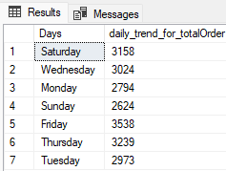

—------------------------------------------------------------------------------------------------

**-- 2. Hourly Trend for Total Order**

**Total Order by Time**

SELECT DATEPART(HOUR, order_time) As Order_Time,

COUNT(DISTINCT(order_id)) As Total_Order

FROM pizza_sales

GROUP BY DATEPART(HOUR, order_time)

ORDER BY DATEPART(HOUR, order_time);

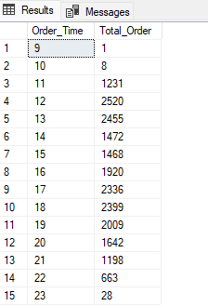

—-----------------------------------------------------------------------------------------

**3. Percentage of Sales by Sales Category**

SELECT * FROM pizza_sales;

SELECT DISTINCT pizza_category, SUM(total_price) *100 / (SELECT SUM(total_price) FROM pizza_sales) As percentage_of_sale

FROM pizza_sales

GROUP BY pizza_category;

-- add sum of total sale also

SELECT pizza_category, SUM(total_price) As Total_sales,

SUM(total_price) * 100 / (SELECT SUM(total_price) FROM pizza_sales) As percentage_of_sale

FROM pizza_sales

GROUP BY pizza_category;

-- find percentage of sales month wise by pizza category

SELECT pizza_category, SUM(total_price) As Total_sales,

SUM(total_price) * 100 / (SELECT SUM(total_price) FROM pizza_sales WHERE MONTH(order_date) =1 )As percentage_of_sale

FROM pizza_sales

WHERE MONTH(order_date) =1

GROUP BY pizza_category;

-- find percentage of sales quarter wise by pizza category

SELECT pizza_category, SUM(total_price) As Total_sales,

SUM(total_price) * 100 / (SELECT SUM(total_price) FROM pizza_sales WHERE DATEPART(QUARTER,order_date) =1 )As percentage_of_sale

FROM pizza_sales

WHERE DATEPART(QUARTER,order_date) =1 -- from jan to april

GROUP BY pizza_category;

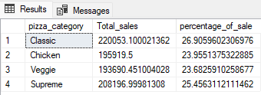

**—---------------------------------------------------------------------------------------**

**4. Percentage of sales by pizza size**

SELECT DISTINCT pizza_size, SUM(total_price) As Total_sales,

CAST(SUM(total_price) * 100 / (SELECT SUM(total_price) FROM pizza_sales) AS DECIMAL(10,2)) As percentage_of_sale

FROM pizza_sales

GROUP BY pizza_size;

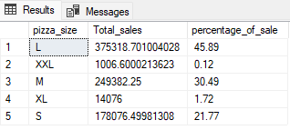

**—----------------------------------------------------------------------------------------**

**5. Total pizza sold by pizza category**

SELECT pizza_category, SUM(quantity) As total_pizza_sold

FROM pizza_sales

GROUP BY pizza_category;

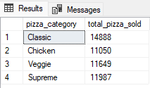

**—---------------------------------------------------------------------------------------**

**6. Top 5 Best sellers by Total pizzas sold**

SELECT TOP 5 pizza_name, SUM(quantity) AS total_pizza_sold

FROM pizza_sales

GROUP BY pizza_name

ORDER BY total_pizza_sold DESC;

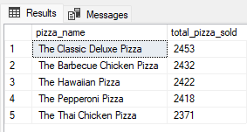

**—---------------------------------------------------------------------------------**

**7. Bottom 5 worst sellers by Total pizzas sold**

SELECT TOP 5 pizza_name, SUM(quantity) As total_pizza_sold

FROM pizza_sales

GROUP BY pizza_name

ORDER BY total_pizza_sold ASC;



